
Blue Team Shooting Sports A.S.S.S. May 26th. 2026
COURSE DESIGNER: Ike Starnes

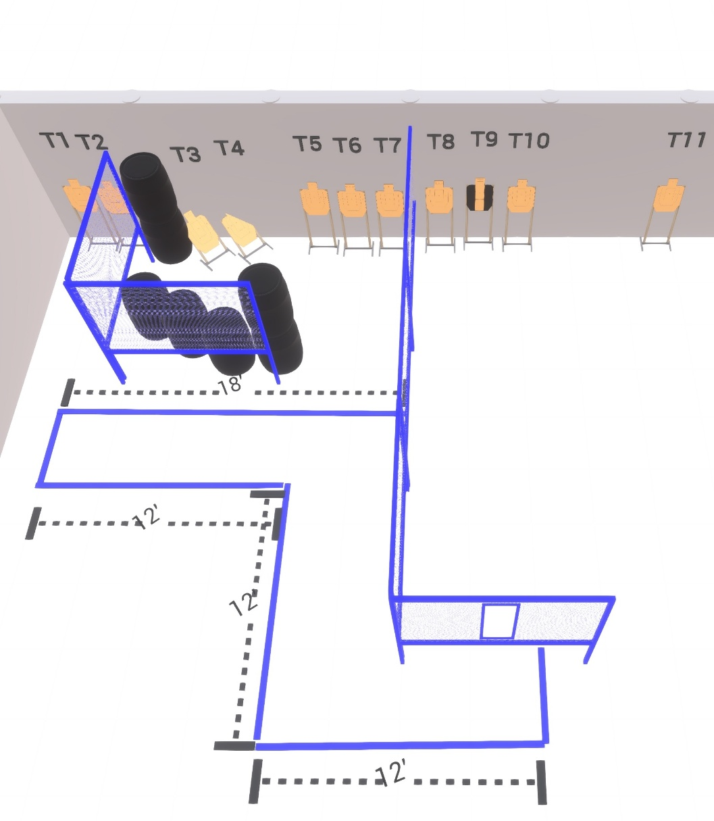

Written Stage Briefings:

Stage 3 – The End - is a 22-round, 110 point, Comstock Course. There are 11 cardboard targets and some noshoots.
Handgun start position Anywhere. Hands touching port. The handgun is loaded and holstered.
PCC start position Muzzle touching port. PCC is loaded with stock touching belt.
On the audible start signal, engage targets from within the shooting area.

